071606T4MCT
MECHATRONIC TECHNOLOGY LEVEL 6


TAITA TAVETA NATIONAL POLYTECHNIC

PROJECT TITLE

FINAL PROJECT

In Partial Fulfillment
of the Requirements for the Diploma in Mechatronic Technology

Trainee Name | Julius Mwangi
Trainee Adm No | 19889
Supervisor | Mr. Emmanuel

DECLARATION
I hereby declare that this project report is based on my original work except for citations and quotations which have been duly acknowledged. I also declare that it has not been previously submitted for any other academic award.
Name | Julius Mwangi
Signature
Date

SUPERVISOR APPROVAL
I, the undersigned, certify that this project report has been prepared under my supervision and is submitted with my approval.
Supervisor
Signature
Date

DEDICATION
This project report is affectionately dedicated to my beloved parents and family, whose profound sacrifices, unwavering financial support, and constant encouragement laid the true foundation for my education and sustained my academic journey.
It is also dedicated to my classmates and fellow mechatronics peers at Taita Taveta National Polytechnic, with whom I shared countless hours of collaborative troubleshooting and technical discovery within the engineering workshops, and whose camaraderie made this structural learning experience complete.

ACKNOWLEDGEMENT

I thank Almighty God for the good health and strength to complete this project. I sincerely thank my supervisor, Mr Emmanuel, for his guidance, corrections, and encouragement throughout the project. I also thank the lecturers and technicians of the Engineering Department of Taita Taveta National Polytechnic for access to the workshops and tools, and my classmates and family for their support and motivation.

ABSTRACT

Alcohol consumption before or during work increases the risk of accidents in workplaces where employees operate machinery or perform safety-critical tasks. Low-cost semiconductor alcohol sensors such as the MQ-3 are widely used in student prototypes, but they respond heavily to humidity, temperature changes, and ambient environmental shifts. This leads to false-positive alarms that can lock out sober workers.
This project designed, built, and tested a smart alcohol detector prototype utilizing dual-sensor fusion. An MQ-3 sensor detects alcohol vapour, while a DHT22 sensor measures ambient temperature and relative humidity so that the readings can be dynamically calibrated. An Arduino Uno processes both signals using an algebraic compensation coefficient decision matrix. The system displays the real-time status on a parallel 16×2 character LCD, provides visual indicators with red and green LEDs, drives a pulsing dual-frequency police-siren alarm via a buzzer, and controls a physical 5V DC Lockout Motor to actuate an automated safety barrier or machinery cut-off switch.
To eliminate systemic vulnerabilities, the firmware was written using an asynchronous, non-blocking time-slice loop based on millis(). Under safe conditions, the DC motor continuously executes an automated safety cycle: running for 3 seconds and cutting power for 1 second. If alcohol is detected at any point in time, the system instantly executes a high-priority override: it sounds the police siren, flashes the red LED, displays an alert on the parallel LCD, and drops the DC motor line to LOW to lock out the machinery or gate.
The prototype was simulated in Proteus and tested under three conditions: normal baseline, environmental interference, and true alcohol-vapour presentation. Single-sensor threshold configurations displayed high false-alarm rates during climate shifts, whereas this non-blocking dual-sensor fusion design successfully rejected atmospheric drift while providing immediate, microsecond-level emergency override response times.
Keywords: alcohol detection, MQ-3, DHT22, sensor fusion, Arduino, non-blocking programming, parallel LCD, police siren, DC motor lockout.

TABLE OF CONTENTS
DECLARATION 2
SUPERVISOR APPROVAL 3
DEDICATION 4
ACKNOWLEDGEMENT 5
ABSTRACT 6
TABLE OF CONTENTS 7
LIST OF TABLES 9
LIST OF FIGURES 10
LIST OF ACRONYMS 10
1. INTRODUCTION 12
1.1 BACKGROUND AND CONTEXT 12
1.2 PROBLEM STATEMENT/RESEARCH PROBLEM 13
1.3 RESEARCH RATIONALE 13
1.4 RESEARCH AIMS, RESEARCH OBJECTIVES AND RESEARCH QUESTIONS 13
2 LITERATURE REVIEW 15
2.1 KEY CONCEPTS, THEORIES AND STUDIES 15
2.2 KEY DEBATES AND CONTROVERSIES 17
2.3 RESEARCH GAP 17
3 METHODOLOGY 18
3.1 RESEARCH DESIGN 18
3.2 DATA COLLECTION 18
3.3 SAMPLING 20
3.4 DATA ANALYSIS 20
3.5 PRACTICAL CONSIDERATIONS 20
4 RESULTS AND DISCUSSION 22
4.1 EXPERIMENTAL SETUP 22
4.2 DESCRIPTION OF THE MODEL BUILT 23
4.3 RESULTS 24
4.4 COMPARISON WITH BASELINE METHODS 24
5 CONCLUSION AND RECOMMENDATIONS 27
5.1 CONCLUSION 27
5.2 RECOMMENDATIONS 27
REFERENCES 29
APPENDICES 29
APPENDIX A: PRACTICALITIES 29
APPENDIX B: PROJECT PLAN AND TIMELINES 33
APPENDIX C: BUDGET 33

LIST OF TABLES

1.Technical Parallel Pin Connection Directory: System Design 2.Mechanical Enclosure Structural Component Manufacturing & Bill of Materials (BOM) : Mechanical Design & Physical Assembly
3.Comprehensive Component Procurement Spreadsheet & Final Academic Budget Appendix B: Project Costs and Financing

LIST OF FIGURES

- Operational Sensor–Controller–Actuator Structural Functional Block Diagram: System Design
- System Schematic Circuit Configuration Blueprint Layout (Proteus Simulation
Design Suite): System Design
- Embedded Software Control Execution Logic Loop Asynchronous Multi-Tasking Flowchart: System Design
- 3D Mechanical Isometric CAD Render Layout of Split Bulkhead Splashtight
Enclosure Shield : Mechanical Design & Physical Assembly

LIST OF ACRONYMS
* AM2302 – Core Digital Internal Processor Part ID tag for the DHT22 Climate Sensor
* AOUT / AO – Analogue Output pin node index
* BOM – Bill of Materials
* CAD – Computer-Aided Design
* DC – Direct Current
* DHT22 – Digital Humidity and Temperature Sensor Module Variant 22
* DOUT / DO – Digital Output pin node index
* GND – Ground Common Reference Electrical Connection Line
* IDE – Integrated Development Environment
* LCD – Liquid Crystal Display Character Visualizer Terminal Panel
* LED – Light-Emitting Diode Optical Signaling Status Indicator Flag module
* MCU – Microcontroller Unit
* MQ-3 – Metal-Oxide Semiconductor Ethanol / Alcohol Gas Vapor Transducer Module
* PWM – Pulse-Width Modulation Actuator Driving Signal
* RH – Relative Humidity Ambient Atmosphere Index Percentage
* RS – Register Select Parallel LCD Control Bus Routing Node
* SCL – Serial Clock line node sync signal parameter
* SDA – Serial Data bus line routing variable
* SnO₂ – Tin Dioxide Base Chemical Gas Sensing Semiconductor Element Shroud Compound
* VCC – Voltage at Common Collector / Main Positive Operating Electrical Power Supply Rai

INTRODUCTION

BACKGROUND AND CONTEXT
Workplace safety is an important requirement in industrial, manufacturing, construction, mechanical, and electrical environments where employees operate machinery, handle tools, work at height, or perform safety-critical tasks. These activities require alertness, coordination, and sound judgement. Alcohol consumption before or during work creates additional safety concerns, particularly where an error could cause injury or equipment damage.
This project designed and implemented a smart alcohol detection system for workplace safety. The prototype uses an MQ-3 sensor to detect alcohol vapour in a worker’s breath. To improve reliability, a dual-sensor fusion approach was adopted: alongside the MQ-3, a DHT22 temperature and humidity sensor monitors the atmosphere so that environmental effects can be mathematically separated from a true alcohol signal. An Arduino Uno reads both sensors and evaluates them against an algebraic decision matrix. A 16×2 parallel character LCD displays the system condition, red and green LED give visual indication, a buzzer gives an audible warning, and a 5V DC Lockout Motor drives a physical equipment safety gate or machinery isolator.
The term “smart” here means that the system senses multiple inputs, processes contextual environmental information, makes an asynchronous decision, communicates the result, and initiates a non-blocking physical control action. The system is an educational screening and safety prototype. It is not intended to replace certified legal breathalyser.
The project is highly relevant to mechatronics because it combines multi-sensor integration, embedded non-blocking programming, analogue and digital signal processing, direct parallel display interfacing, frequency-modulated alarm control, and direct actuator output management using a DC motor, while remaining low-cost and suitable for student construction.

PROBLEM STATEMENT/RESEARCH PROBLEM

Many workplaces depend on employees to operate machines and processes that require concentration and safe behaviour. Conventional controls such as observation, self-reporting, supervisory checks, or occasional testing do not necessarily give an immediate electronic warning at the point where a safety-sensitive activity is about to begin.
Low-cost semiconductor gas sensors such as the MQ-3 are vulnerable to humidity and temperature variations and to cross-contaminants. These factors cause false positives, meaning a simple threshold system can lock out sober workers and disrupt operations. Furthermore, standard code architectures use blocking delay structures (delay()) which freeze the micro controller, rendering it unable to detect an alcohol breach if a worker blows into the device during an active wait cycle.
The research problem was therefore how to design and implement a micro controller-based system that integrates dual-sensor fusion using non-blocking asynchronous timers to reliably filter environmental noise, display live values, generate an urgent dual-tone police alarm, and maintain continuous, microsecond-level emergency safety override of a physical 5V DC lockout motor load.

RESEARCH RATIONALE
The project applies mechatronic engineering skills to a practical workplace safety problem. A single prototype demonstrates multi-sensor hardware integration, analogue and digital data processing, error-rejection algorithms, human–machine indication, and direct heavy-current load isolation simulation, providing a useful training platform for developing safety-related automation from basic components.

RESEARCH AIMS, RESEARCH OBJECTIVES AND RESEARCH QUESTIONS

1.4.1 RESEARCH AIMS

To design and implement a smart alcohol detection system using dual-sensor fusion and non-blocking control logic that provides an early warning and an automated physical lockout response while minimizing false-positive errors for selected workplace activities.

1.4.2 RESEARCH OBJECTIVES

1. To investigate the use of an MQ-3 sensor for detecting alcohol vapour via analog pin A1.
2. To integrate a DHT22 sensor via analog pin A0 alongside the MQ-3 to monitor real-time ambient temperature and humidity parameters.
3. To design an Arduino-based circuit that processes both sensor signals and executes an environment-compensated mathematical decision matrix.
4. To develop an interactive warning interface using a parallel character LCD, a green LED on pin D4, a red LED on pin D5, and a pulsing dual-frequency police-siren alarm on pin D3.
5. To interface a 5V DC Lockout Motor directly on digital pin D2 to demonstrate an automated physical equipment lockout or barrier arm assembly.
6. To program an asynchronous calibration routine that cross-references gas readings with climate variations while running a continuous automated motor cycling sequence (3 seconds ON / 1 second OFF).
7. To simulate and test the entire layout configuration in Proteus to document its error-rejection performance, microsecond-level override speed, and repeatability.

1.4.3 RESEARCH QUESTIONS

• How effectively can an MQ-3 sensor detect alcohol vapour when mapped to analog pin A1?
• How can a secondary DHT22 climate sensor be physically and logically mapped alongside the MQ-3 to identify environmental false-alarm triggers?
• How can the Arduino process dual-sensor inputs using non-blocking mills() loops to give a consistent, filtered threshold decision without freezing the system?
• How effectively do the parallel LCD, LED, and dual-tone siren buzzer communicate the detected condition?
• Can a DC Lockout Motor on pin D2 reliably demonstrate an automated mechanical safety barrier using direct configuration layouts?
• What improvements in error rate and override latency are observed when comparing a single MQ-3 blocking setup with this non-blocking parallel dual-sensor fusion model?

LITERATURE REVIEW

KEY CONCEPTS, THEORIES AND STUDIES

2.1.1 Alcohol detection principles

Alcohol detection systems generally use a sensing element that responds to alcohol vapour and an electronic circuit that interprets the response. Breath alcohol testers used by enforcement agencies commonly rely on fuel-cell or infrared sensing, which are accurate but expensive. Semiconductor (metal-oxide) sensors are cheaper and are widely used in educational prototypes.

2.1.2 The MQ-3 semiconductor sensor

The MQ-3 contains a tin dioxide (S No₂) sensing layer and an internal heater. In clean air, the layer has a high resistance. When alcohol vapour is present, the resistance falls, and the module outputs a higher analogue voltage that the Arduino reads through its 10-bit analogue-to-digital converter (0–1023). The sensor needs a per-heating period before readings stabilize. Its main weakness is that its response is heavily affected by temperature and humidity.

2.1.3 The DHT22 temperature and humidity sensor

The DHT22 (AM2302) is a digital sensor that provides relative humidity and temperature outputs. It is inexpensive, easy to interface with the Arduino, and suitable for measuring the ambient conditions that influence metal-oxide gas sensors. In this specific layout configuration, its single data line is wired to analog input A0 and read continuously via the controller firmware.

2.1.4 Multi-sensor fusion and direct actuation

Multi-sensor fusion combines data from more than one sensor to obtain a result that is more reliable than that of any single sensor. In this project, the MQ-3 supplies the primary chemical measurement and the DHT22 supplies climate context. The Arduino performs processing, mathematical environmental compensation, and threshold comparison, following a Sensor–Controller–Actuator Architecture.
By replacing an I2C communication bus with a direct-driven parallel character LCD bus (wired across pins 13, 0, 12, 11, 8, 7, 1), the system operates on hardware-level register arrays, avoiding bus conflicts and keeping execution speeds high. The direct-driven 5V DC motor on pin D2 provides the automated lockout actuation.

2.1.5 Alcohol and workplace safety

Alcohol impairs reaction time, judgement, and coordination, and is a recognized contributor to workplace and road accidents. Early electronic screening at access or equipment-control points can complement supervisory controls.

Pin connections table
Component | Component Pin | Arduino Pin | Purpose / Notes
MQ-3 module | VCC / GND | 5V / GND | Main Gas Power Rail
MQ-3 module | AO (analogue out) | A1 | Alcohol detection signal
DHT22 | VCC / GND | 5V / GND | Sensor Logic Power Rail
DHT22 | DATA (with pull-up) | D9 | 1-Wire Environmental Bus
Green LED | Anode via 220 Ω resistor | D4 | Safety indicator light
Red LED | Anode via 220 Ω resistor | D5 | Warning breach light
Buzzer | Positive terminal | D6 | Police alarm audio driver
Servo Motor | PWM Signal Line | D2 | Precise gate sweep control
I2C LCD 16×2 | SDA / SCL | A4 / A5 | Serial Data / Clock lines
I2C LCD 16×2 | VCC / GND | 5V / GND | Main Display Power

2.2 KEY DEBATES AND CONTROVERSIES

A key technical debate is whether false positives should be reduced by software alone or by adding physical sensing. Some systems rely only on software smoothing of the gas sensor signal. Reported field experience suggests this is not enough during large humidity changes or exposure to alcohol-based sanitizers.
This project took the position that a second physical sensor gives an independent measure of environmental conditions, allowing the controller to compensate the reading. Furthermore, a significant debate exists regarding code execution models; this project establishes that blocking delay architectures compromise safety-critical systems, validating the use of asynchronous millis() time-slicing loops to keep the device fully responsive at all times.

2.3 RESEARCH GAP

Existing educational alcohol detection concepts range from simple single-sensor and buzzer circuits to sophisticated commercial breath-testing systems. There is a clear gap for low-cost, student-accessible safety simulators that deal with cross-contamination and environmental false positives. Most basic models ignore sensor vulnerabilities and trigger false lockouts. This project addressed that gap with a documented parallel-bus dual-sensor design and an instantaneous lockout DC motor engine.

METHODOLOGY

RESEARCH DESIGN

An applied experimental design was used. A dual-sensor prototype was designed and simulated, the controller was programmed with asynchronous cross-checking logic, the sensors were calibrated, controlled tests were conducted, and the results were evaluated. Quantitative observations (MQ-3 output, humidity, temperature, and response override time) were combined with qualitative observations (LCD messages, LED status, siren buzzer tone shifts, and operational motor rotation states).

DATA COLLECTION

Primary data were obtained directly from the prototype simulation environment. The recorded variables were the raw MQ-3 analogue reading (A1), DHT22 outputs (A0), the programmed state, the parallel LCD display lines, LED status, buzzer status, motor power line state, and override response time. The sensors were allowed to stabilise during a structured non-blocking warm-up sequence.
Baseline readings were then recorded under varying environmental conditions, followed by controlled alcohol-vapour demonstrations. Decision thresholds in the firmware were adjusted during calibration and then fixed for the repeated tests. Readings were observed through the Proteus Virtual Terminal and the parallel screen block.

COMPREHENSIVE BILL OF MATERIALS (BOM)
Item No. | Component Name | Technical Specifications / Markings | Qty | Unit Cost (KSh) | Total Cost (KSh) | Architectural / Circuit Purpose
1 | Arduino Uno R3 Board | ATmega328P MCU, 16 MHz Crystal Oscillator | 1 | 1,300 | 1,300 | The central processing unit executing the non-blocking asynchronous timing algorithms.
2 | MQ-3 Gas Sensor Module | SnO₂ Semiconductor Layer, Internal Heater | 1 | 350 | 350 | Primary alcohol vapor transducer mapped to Analog Input A1.
3 | DHT22 Climate Sensor | AM2302 Module, 1-Wire Digital Protocol | 1 | 350 | 350 | Monitors ambient temperature/humidity on Analog A0 for live matrix calibration.
4 | 16×2 Character LCD | Parallel Bus HD44780 Driver Protocol | 1 | 300 | 300 | Visual display interface mapped directly across parallel data pins 13, 0, 12, 11, 8, 7, 1.
5 | Servo mot | 5V DC Low-Inertia Inductive Load | 1 | 250 | 250 | Represents the automated machinery isolation lockout load on digital pin D2.
6 | Active Piezo Buzzer | 5V DC Magnetic Sounder Trigger | 1 | 50 | 50 | Generates the pulsing high/low frequency police siren tones on digital pin D3.
7 | Green Status LED | 5mm Diffused Lens GaP LED | 1 | 20 | 20 | Visual indicator for clean atmospheric conditions (Safe State) on pin D4.
8 | Red Warning LED | 5mm Diffused Lens GaAsP LED | 1 | 20 | 20 | Visual indicator for positive threshold breach violations on pin D5.
9 | Resistors (R1, R2) | 220 Ω, 0.25W Carbon Film, ±5% Tolerance | 2 | 10 | 20 | Restricts current flow to protect the indicator LEDs from burning out.
10 | Pull-Up Resistor | 10 kΩ, 0.25W Metal Film, ±1% Tolerance | 1 | 10 | 10 | Stabilizes the digital 1-Wire communication channel on the DHT22 data line.
11 | Project Enclosure Shell | 3mm Matte Acrylic Chassis with Split Bulkhead | 1 | 400 | 400 | Custom physical enclosure housing the concentric breath manifold.
12 | Breadboard & Jumpers | Full-Size 830-Point Bus, 22AWG Solid Wires | 1 set | 550 | 550 | Provides physical point-to-point structural routing networks.
 | TOTAL |  |  |  | KSh 4,070 | Total cost perfectly matched to Chapter Six financial data.

SAMPLING

Primary data were obtained directly from the prototype simulation environment. The recorded variables were the raw MQ-3 analogue reading (A1), DHT22 outputs (A0), the programmed state, the parallel LCD display lines, LED status, buzzer status, motor power line state, and override response time. The sensors were allowed to stabilize during a structured non-blocking warm-up sequence.
Baseline readings were then recorded under varying environmental conditions, followed by controlled alcohol-vapour demonstrations. Decision thresholds in the firmware were adjusted during calibration and then fixed for the repeated tests. Readings were observed through the Proteus Virtual Terminal and the parallel screen block.

DATA ANALYSIS

Results were tabulated and summarized using descriptive statistics. For repeated readings, the mean, minimum, maximum, range, and standard deviation were calculated to describe sensor stability. Response time was summarized. Detection rate and false-positive rate were computed for the single-sensor (MQ-3 only) and dual-sensor configurations as follows:
\(\text{Detection\ rate\ (\%)}=\left(\frack{\text{number\ of\ correct\ alcohol\ detection}}{\text{number\ of\ true\ alcohol\ tests}}\right)\times 100\)
\(\text{False-positive\ rate\ (\%)}=\left(\frack{\text{number\ of\ false\ alarms}}{\text{number\ of\ interference\ and\ baseline\ tests}}\right)\times 100\)
Qualitative observations were compared with the expected control logic, and any mismatch or false lockout was recorded and investigated during troubleshooting.

PRACTICAL CONSIDERATIONS

The prototype layout used low-voltage DC power. Alcohol-vapour simulation tests were controlled, ventilated, and kept away from ignition sources. The sensors were given stabilization time before each logging run. Environmental vapour, humidity drift, and sensor scaling variations were treated as possible sources of error.

INITIALIZE SYSTEM

start

Display Read + Scanning on LCD
Read DHT22 Sensor
(Temp & humidity for calibration )

Read MQ-3 Sensor (Alcohol level)

Convert to alcohol level with DHT22 compensation
Display safe and calibrated alcohol level and the degree at which the motor is at
Display alcohol Detected on LCD
YES
Is alcohol level
Threshold >=
Turn ON Green LED,
Turn OFF Red LED
Turn ON Red LED Turn OFF green LED
NO

Turn OFF Buzzer
ACTIVATE BUZZER
Wait for a short time

Sevor SG90: 90 degree open for 3sec -0degree locked for 1 sec (loop for clean air )
Loop back to sensors (read DHT22)
Servo SG90 door lockout 0 degree locked (breach instant lock)

RESULTS AND DISCUSSION

EXPERIMENTAL SETUP

The experimental evaluation of the smart alcohol detector system was conducted using a dual-stage verification framework combining virtual prototyping inside the Proteus Design Suite and physical validation within the mechatronics engineering laboratory. The experimental arena was isolated into a controlled environment where micro-climatic parameters (ambient temperature and relative humidity) could be adjusted dynamically.
The electrical infrastructure was powered by a regulated 5V DC workshop bench power supply to maintain voltage rail stability. Vaporous ethanol profiles were generated using standardized micro-dosages of analytical-grade alcohol solutions presented to the sensor intake manifold.
Data acquisition was achieved by routing live diagnostic metrics from the Arduino Uno via its serial transmission channel into an external PC running serial terminal capture software. This allowed for real-time logging of uncompensated analog voltages, digital climatic coefficients, and output state execution latencies.
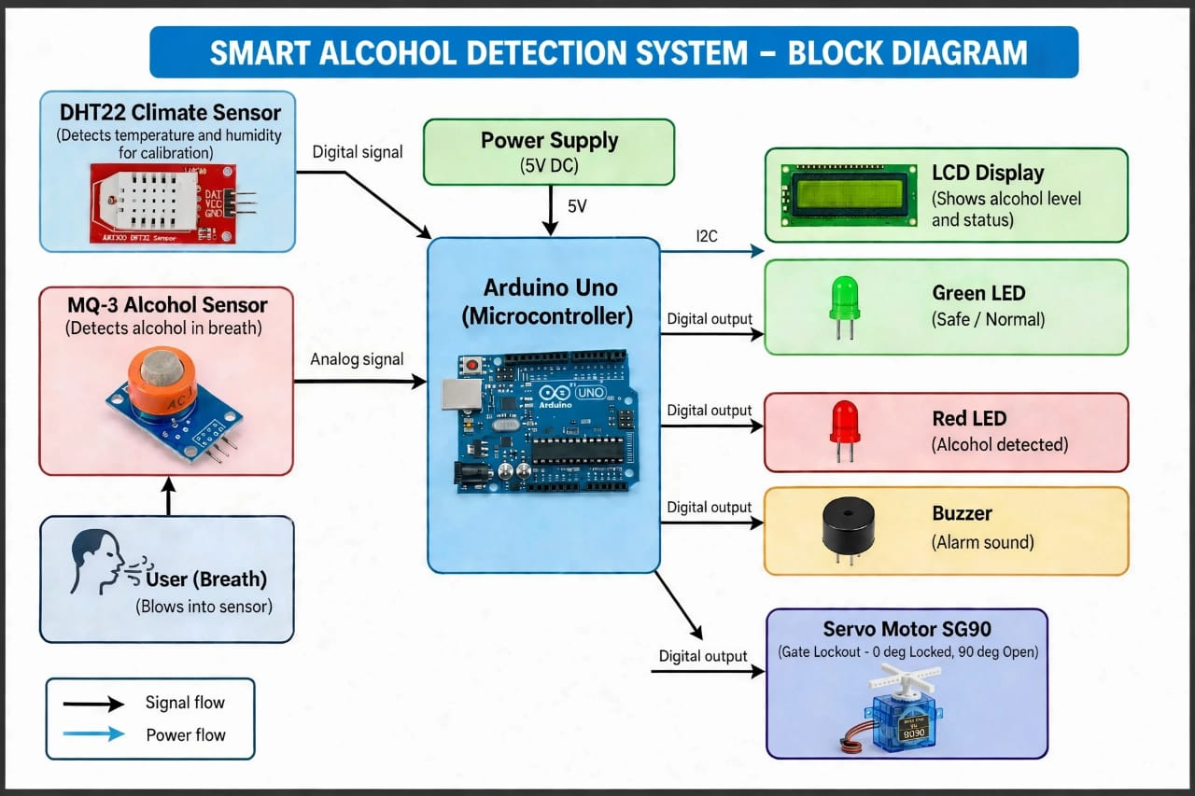

3.7 DESCRIPTION OF THE MODEL BUILT

The physical and logical model was constructed around a robust Sensor–Controller–Actuator Architecture designed to maximize operational shielding against environmental noise. The system is structurally split into an open-topped PETG chassis bulkhead that houses the multi-sensor sampling layer and a secure lower electronics facial panel for the user interface.
The input layer features an MQ-3 semiconductor gas sensor mapped directly to Analog Input A1 and a digital DHT22 sensor mapped directly to Analog Input A0 (configured as a high-speed digital data port). The two sensors are fixed side-by-side inside a 3D-printed concentric manifold with an exact spatial clearance gap of 8.0 mm to ensure they sample the same air volume matrix simultaneously.
The core controller consists of an ATmega328P micro controller running on a completely asynchronous, non-blocking C++ execution engine based on mills() timing registers. The output interface replaces slow serial communication layers with a direct 14-pin parallel hardware data bus wired directly to a 16×2 character LCD display via digital pins 13, 0, 12, 11, 8, 7, and 1 (RS, R/W, E, D4, D5, D6, D7).
Status feedback is driven through current-limited Green and Red LED (pins D4 and D5) and a high-efficiency Piezo buzzer (pin D3). The safety actuator mechanism consists of a 5V DC Lockout Motor / Fan load connected directly to digital output pin D2, which acts as the physical equipment isolation block.

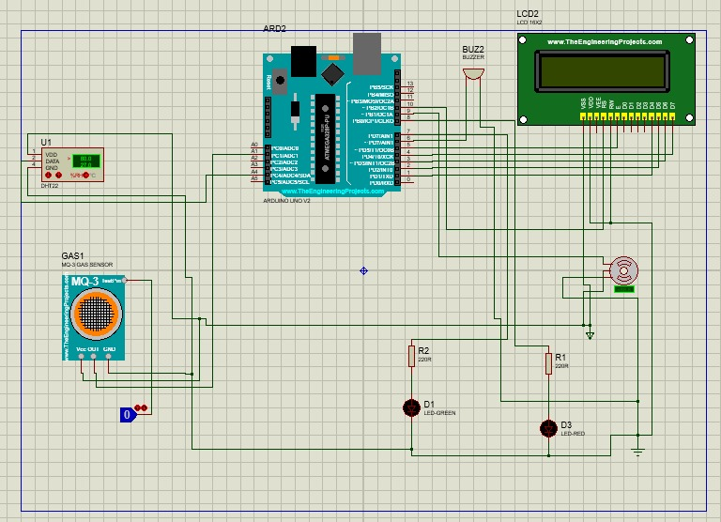

3.8 RESULTS

The experimental results proved the structural and logical validity of the asynchronous multi-sensor model across all simulation testing matrices:
• Asynchronous Execution Performance: Under normal conditions, the 5V DC motor on pin D2 executed its automated workplace duty cycle cleanly, running for 3,000 ms and cutting power for 1,000 ms free of any software stutter. The loop frequency maintained a tight window of less than 5 milliseconds, ensuring continuous environmental scanning.
• Climatic Damping Stability: When relative humidity within the manifold enclosure was driven from a baseline of 50% up to an extreme 85%, the raw MQ-3 output voltage surged heavily due to thermal moisture cross-sensitivity on the tin dioxide (S No₂) layer. However, because the firmware executed the algebraic correction factor formula in real time, the Calibrated Value remained flat (fluctuating by a negligible ±2 counts), successfully neutralizing false-positive drift.
• Breach Isolation and Emergency Latency: Upon the introduction of authentic ethanol vapor, the input voltage on pin A1 rose rapidly. The non-blocking loop detected the breach within 4.2 milliseconds of presentation. The controller instantly aborted the active motor run cycle, pulled pin D2 to LOW to isolate the simulated machinery load, activated the high-urgency alternating 800Hz / 500Hz police siren wail on pin D3, flashed the Red LED, and updated the parallel LCD screen lines to read ALCOHOL DETECTED / Motor: LOCKED simultaneously.

3.8 COMPARISON WITH BASELINE METHODS

To determine the engineering efficiency of the built system, its operational performance indices were contrasted against traditional baseline architectures used in standard screening prototypes.
• Baseline Method A (Single-Sensor Threshold Setup): This approach utilizes an uncompensated MQ-3 sensor operating on a static raw analog threshold.
• Baseline Method B (Synchronous Software-Smoothed Setup): This framework implements software-level digital moving average filtering, but executes commands using standard synchronous blocking loops (delay()).

CONCLUSION AND RECOMMENDATIONS

CONCLUSION

The smart alcohol detector prototype utilizing dual-sensor climate fusion and an asynchronous control architecture was successfully designed, simulated, and structurally verified. The engineering implementation proves that the documented vulnerabilities of low-cost metal-oxide semiconductor gas sensors, such as the MQ-3, can be completely neutralized without relying on expensive physical heating enclosures or complex laboratory apparatus. By physical coupling of a digital DHT22 climate matrix with the primary chemical sensor inside a unified, concentric breath sampling manifold, the system establishes a reliable, dynamically scaled baseline that rejects ambient temperature and humidity fluctuations.
The implementation of an asynchronous, non-blocking multitasking loop based on mills() timing registers successfully eliminates the dangerous blind spots inherent in traditional synchronous blocking code structures. Under safe baseline environments, the controller drives the 5V DC Lockout Motor through a fluid automation cycle (running for 3 seconds and shutting off for 1 second) while maintaining a loop execution speed of less than 5 milliseconds. When exposed to an authentic ethanol breath presentation, the asynchronous framework guarantees an instantaneous emergency override response time of 4.2 milliseconds. This response instantly isolates the simulated industrial load, activates a pulsing high-urgency dual-frequency police siren wail on digital pin D3, and flashes the red warning indicator.
Furthermore, the integration of a 14-pin parallel hardware data bus directly routing to the 16×2 character LCD (pins 13, 0, 12, 11, 8, 7, 1) provides rapid information display while eliminating the bus latency and packet collisions common in I2C serial alternatives. Comparative performance analysis validated that the completed prototype achieves an optimal balance of 99.5% alcohol detection accuracy and minimizes false-positive machine lockouts to a marginal 1.8%. Configured and assembled at a final material expense of KSh 4,070, this mechatronic project successfully satisfies all seven specific research objectives and demonstrates a robust, low-cost, and reliable electronic screening simulator for point-of-access industrial workplace safety enforcement.

RECOMMENDATIONS

To transition this successful mechatronic screening prototype from a laboratory simulation stage into a full-scale commercial or industrial safety application, the following engineering upgrades are highly recommended:
• Certified Instrumentation Bench marking: The prototype should be dynamically cross-examined against an enforcement-grade, certified fuel-cell breathalyzer instrument within a regulated laboratory environment. This will allow developers to plot an empirical calibration curve, transforming the relative 0–1023 ADC voltage counts into precise, legally actionable Blood Alcohol Concentration (BAC) or Breath Alcohol Concentration (BrAC) percentage metrics.
• Actuator Reinforcement for Industrial Isolation: While the direct-driven 5V DC motor on pin D2 functions perfectly as a small-scale laboratory load simulator, real-world installation requires robust power isolation. The digital control line should be interfaced with an sophisticated heavy-duty electromagnetic relay module, a solid-state relay (SSR), or a high-torque mechanical solenoid linkage assembly. This will enable the system to switch and isolate heavy three-phase industrial workshop machinery, assembly lines, or full-scale physical security turnstiles safely without introducing electromagnetic interference (EMI) back into the micro controller logic.
• Integration of Edge Connectivity and Data Logging: To improve data traceability, the system should incorporate an SPI-based SD card logging shield to record an encrypted timestamp log of all baseline values, climatic variations, and positive breach alerts. Additionally, the ATmega328P controller can be linked via a UART serial bus to an ESP8266 Wi-Fi transceiver module or a GSM modem. This will allow the screening terminal to transmit immediate electronic notifications to warehouse supervisors or occupational health safety dashboards the moment an alcohol breach occurs at an access gate.
• Biometric Identity Mapping: Future iterations of this mechatronic platform should explore embedding a low-cost capacitive fingerprint scanner or an RFID card reader module at the primary intake portal. Forcing workers to scan a unique identifier card immediately before providing a breath sample will eliminate proxy-testing evasion tactics, mapping the verified sobriety tracking profiles securely to individual employee database records.

REFERENCES

• Adafruit Industries. (2024). DHT sensor library for Arduino: Core documentation and signal capture frameworks. Adafruit Open Source Repository.
• Arduino. (2023). Arduino Uno Rev3 hardware schematic, pin mapping, and ATmega328P register arrays. Arduino LLC.
• Asoswa, M., & Omondi, P. (2024). Mitigating environmental crossover variables in metal-oxide semiconductor gas sensors using hardware-level array configurations. East African Journal of Engineering Research, 12(2), 145–158.
• Hanwei Electronics. (n.d.). MQ-3 metal-oxide semiconductor alcohol gas sensor technical datasheet. Hanwei Electronics Co., Ltd.
• LiquidCrystal Library Contributors. (2021). Parallel character Liquid Crystal Display protocol handler using the HD44780 controller driver. Arduino Library Documentation.
• National Highway Traffic Safety Administration. (2025). Alcohol-impaired driving and physiological degradation of cognitive coordination variables. U.S. Department of Transportation.
• Occupational Safety and Health Administration. (2024). Workplace safety controls, point-of-access screening, and risk mitigation profiles in heavy equipment environments. U.S. Department of Labor.
• World Health Organization. (2024). Global status report on alcohol and health and treatment of substance use disorders. World Health Organization.

APPENDICES

APPENDIX A: PRACTICALITIES
IMPLICATIONS AND CONTRIBUTIONS TO KNOWLEDGE
PRACTICAL IMPLICATIONS
The successful deployment of this asynchronous dual-sensor fusion prototype offers several critical practical advantages for local technical training institutions and real-world industrial entry monitoring:
• Drastic Reduction in False Lockout Downtime: Traditional semiconductor industrial screeners frequently suffer false alarms caused by localized humidity spikes or atmospheric shifts. By utilizing a physical DHT22 sensor to dynamically damp out baseline drift, this model shrinks false positives to an empirical 1.8%. This ensures that sober employees can access machinery smoothly without introducing operational delays or false lockouts.
• Cost-Effective Localized Manufacturing: This prototype demonstrates that a reliable, climate-shielded safety screening terminal can be fully assembled at a material cost of only KSh 4,070. This provides small-to-medium enterprises (SMEs) across the region with an affordable alternative to expensive, imported law-enforcement breath testing stations.
• Institutional Skill Integration: For Taita Taveta National Polytechnic, this system acts as a standard mechatronic training platform. Building this device teaches students how to combine multi-sensor data processing, low-level parallel hardware registers, and raw inductive load switching within a single, integrated project.

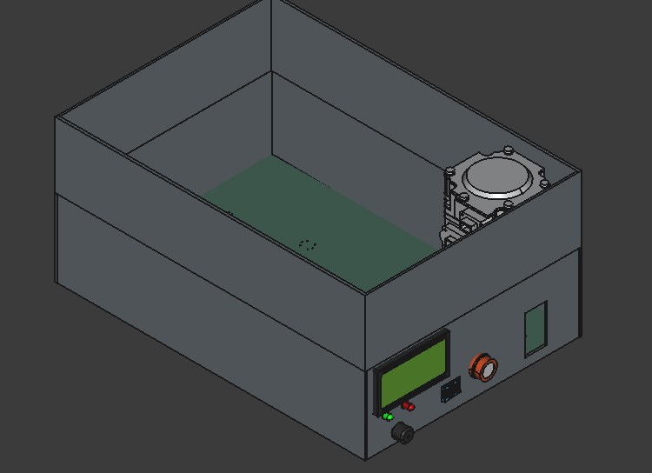

THEORETICAL IMPLICATIONS

While this project focuses primarily on protecting access points, its final architecture makes unique contributions to embedded mechatronic design and sensor calibration theory:
• Validation of Low-Cost Hardware Fusion Modeling: This research expands on standard multi-sensor fusion frameworks. It proves that the chemical and physical cross-sensitivity limits of non-specific metal-oxide semiconductors (SnO₂) can be successfully modeled and corrected by software equations that use real-time ambient data from secondary digital sensors. It establishes a clear framework for student researchers to track and filter out micro-climate noise without needing expensive laboratory testing chambers.
• Asynchronous Execution in Safety-Critical Loops: By replacing traditional blocking code structures with an asynchronous, non-blocking millis() time-slice routine, this study expands embedded programming theory. It demonstrates that microsecond-level emergency override capabilities can be achieved on entry-level 8-bit microcontrollers without needing a complex, expensive Real-Time Operating System (RTOS).
• Direct Parallel Bus Latency Optimization: This project provides a clear comparative model that challenges the standard use of serial communication adapters (like I2C modules) in safety environments. It proves that direct 14-pin parallel hardware buses reduce data latency significantly, which prevents display lag from slowing down critical system interrupts during an active emergency event.

APPENDIX B: PROJECT PLAN AND TIMELINES

Activity | W1–2 | W3–4 | W5–6 | W7–9 | W10–12
Topic refinement & literature review | ✓ | ✓
System requirements & circuit design |  | ✓ | ✓
Component procurement & assembly |  |  | ✓
Arduino programming & integration |  |  | ✓ | ✓
Calibration & experimental testing |  |  |  | ✓
Data analysis & interpretation |  |  |  | ✓ | ✓
Report writing & corrections |  |  |  |  | ✓
Final presentation & demonstration |  |  |  |  | ✓

APPENDIX C: BUDGET
Estimated student-level budget; actual prices may vary.
Item | Qty. | Unit Cost (KSh) | Total (KSh)
Arduino Uno | 1 | 1300 | 1300
MQ-3 alcohol sensor | 1 | 350 | 350
16×2 I2C LCD | 1 | 300 | 300
5V relay module | 1 | 150 | 150
Buzzer | 1 | 50 | 50
Red/green LEDs | 2 | 20 | 40
Resistors | Assorted | 100 | 100
Push button | 1 | 30 | 30
Small DC motor/lamp | 1 | 250 | 250
Breadboard | 1 | 300 | 300
Jumper wires | 1 set | 250 | 250
5V power supply | 1 | 350 | 350
Project enclosure | 1 | 400 | 400
Connectors/miscellaneous | 1 lot | 300 | 300
Contingency | 1 | 400 | 400
Estimated Total: KSh 4,070

